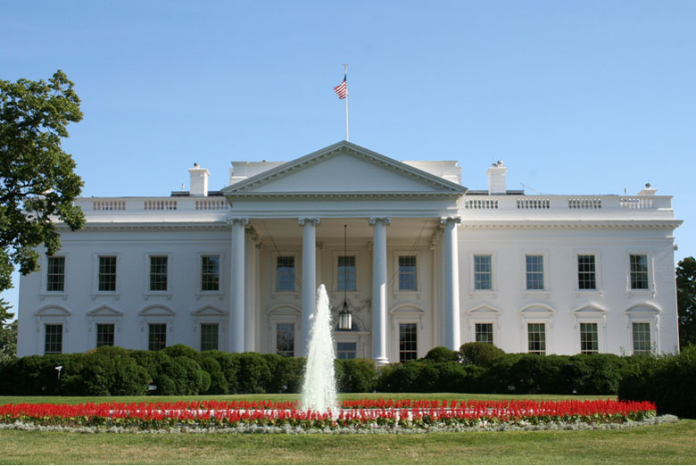US and Canada Study Guide
Mr. Licker’s test will be on Friday May 24th
We will be reviewing in class on Thursday May 23rd

Below are the topics you will be tested on. Please look through your notes for any information you have on these topics and pull them together to help you complete the review sheet on Thursday. There will be no geography/states/provinces/capitals on this test!

Topics to Know for the Test:

Settlement of Canada:
English Settlement – came from England for religious and political reasons; settled the original 13 colonies

Spanish Settlement – came from Spain to spread Christianity to the Native Americans

French Settlement – came from France for Fur Trapping and Trade; settled near the Mississippi River and the St. Lawrence River

Know the definitions for the following words:
Indigenous

Bilingual ***Hint the prefix Bi- means 2***

Democracy

US and Canadian Government:
Know the 3 branches of US government and their jobs
Executive Branch – execute or carry-out laws
Judicial Branch – judge laws
Legislative Branch – create laws

Know the national capitals of Canada and the United States
United States capital –
Canada’s capital –

Know the Heads of Government for United States and Canada
United States –
Canada –

Define Bicameral –

Be able to give 2 similarities and 2 differences between the U.S. and Canadian Governments

Think About the following:
** How many branches of government
** Names of the Branches of Government
** Type of Government
** Jobs of the Branches of Government
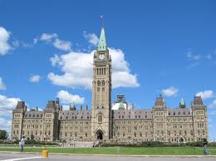

Know the 2 houses in Canadian Parliament –

Know the 2 houses in US Congress -

Know the province in Canada that wants to separate –

Which law made Canada a self-governing country?

2 Countries that fought the French and Indian War – France and England
What were they fighting over? Land and trade routes

Territory created for the Inuit – Nunavut

Know what the Inuit used to hunt and what they used for transportation

